Lab 5
Nouman Ali
Su92-bsaim-f25-118
AI-3B
Minimax Game-Tree Trace
Task
Trace the supplied game tree by hand using the Minimax algorithm.
1. Given terminal scores
The Minimax example on page 23 of the lab manual supplies the terminal scores [3, 5, 2, 9, 0, 7]. The code pads the list with zeros to form a complete binary tree of depth 3. Therefore, the eight leaf values used in the trace are:
[3, 5, 2, 9, 0, 7, 0, 0]
2. Game-tree structure
The root is a MAX node. Its children are MIN nodes, and the next level contains MAX nodes. The terminal scores are evaluated from left to right.
MAX (Root)
/ \
MIN (A) MIN (B)
/ \ / \
MAX MAX MAX MAX
/ \ / \ / \ / \
3 5 2 9 0 7 0 0
3. Minimax calculation (bottom-up)
Step 1 — MAX level (take the larger value from each pair):
MAX node | Leaf values | Result
MAX 1 | max(3, 5) | 5
MAX 2 | max(2, 9) | 9
MAX 3 | max(0, 7) | 7
MAX 4 | max(0, 0) | 0
Step 2 — MIN level (take the smaller value from each pair):
MIN node | Child values | Result
MIN A | min(5, 9) | 5
MIN B | min(7, 0) | 0
Step 3 — Root MAX decision:
MAX(5, 0) = 5
4. Final result and interpretation
The Minimax value at the root is 5. MAX should choose the left branch (MIN A), because its guaranteed outcome is 5, while the right branch (MIN B) has value 0. MIN is assumed to choose the smallest available value at its level, representing the opponent’s best response against MAX.
Conclusion
By evaluating the leaves first and moving upward, the supplied tree gives a root value of 5. Thus, the optimal move for MAX is the left subtree.

Leaf-Evaluation Counter for Minimax and Alpha-Beta
Task
Add a leaf-evaluation counter to both algorithms. The counter increases whenever an algorithm reaches a terminal (leaf) node and reads its score.
1. Test data
To compare both algorithms fairly, the same complete binary tree is used for both. The Minimax example on page 23 of the lab manual gives [3, 5, 2, 9, 0, 7] and pads it with zeros to make eight leaves.
Leaf scores = [3, 5, 2, 9, 0, 7, 0, 0]
2. Python implementation
A shared counter dictionary is passed to each recursive function. It is incremented only in the base case.
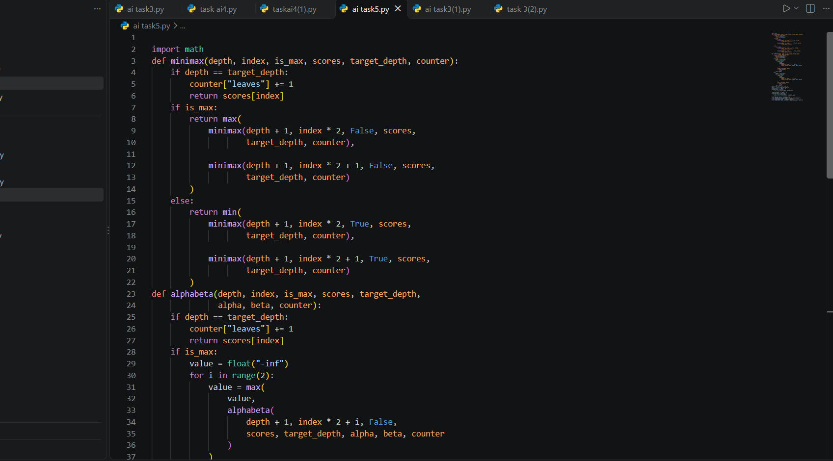
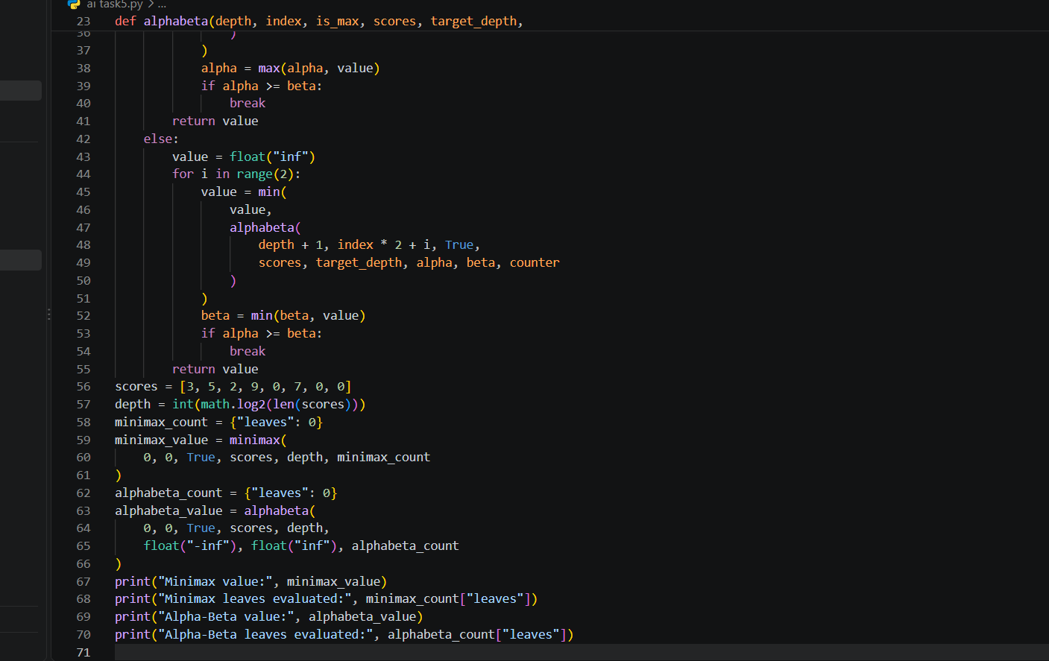

3. Expected output
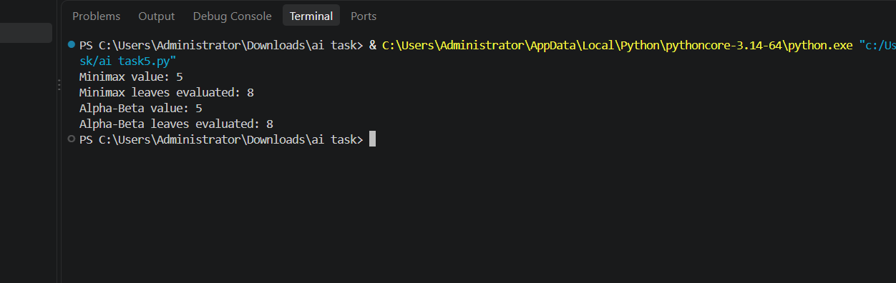
4. Comparison
Algorithm | Root value | Leaves evaluated
Minimax | 5 | 8
Alpha-Beta Pruning | 5 | 7
Minimax evaluates all eight terminal leaves because it explores the complete tree. Alpha-Beta evaluates seven leaves in this left-to-right ordering. After the right MIN node has found a value of 0 while the root already has alpha = 5, the remaining final leaf cannot improve the root decision, so that branch is pruned.
5. Conclusion
Both algorithms return the same optimal Minimax value (5), confirming that pruning does not change the decision. The leaf counter shows that Alpha-Beta evaluates one fewer leaf than plain Minimax for this tree and ordering. The amount of pruning can vary when branch ordering changes.
Note: The lab manual’s Alpha-Beta demonstration uses a different example score list. For a meaningful leaf-count comparison in this task, both algorithms above are run on the same eight-leaf tree derived from the Minimax example.

Branch Ordering and Alpha-Beta Pruning
Task
Reorder branches and observe how pruning changes while the Minimax value remains the same.
1. Test tree and original ordering
The lab manual (page 23) provides the Minimax terminal scores [3, 5, 2, 9, 0, 7]. Its code pads this list with zeros to create a complete binary tree. The original eight-leaf order is therefore [3, 5, 2, 9, 0, 7, 0, 0].
Original leaves: [3, 5, 2, 9, 0, 7, 0, 0]
2. Reordered branches
The children are reordered without changing the values in the game tree. At the left MIN node, visit the MAX child [2, 9] before [3, 5]. At the right MIN node, visit the MAX child [0, 0] before [0, 7]. This gives the reordered leaf sequence:
Reordered leaves: [2, 9, 3, 5, 0, 0, 0, 7]
This is a move-ordering change only: each MAX/MIN node still has the same children and the same terminal utilities. Only the order in which children are examined is different.
3. Python code

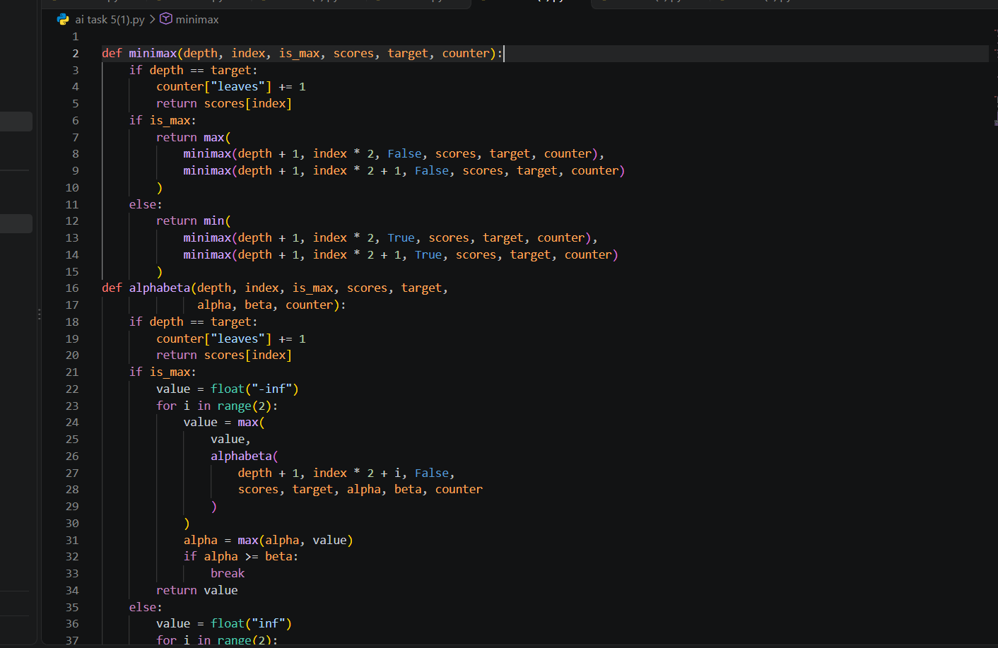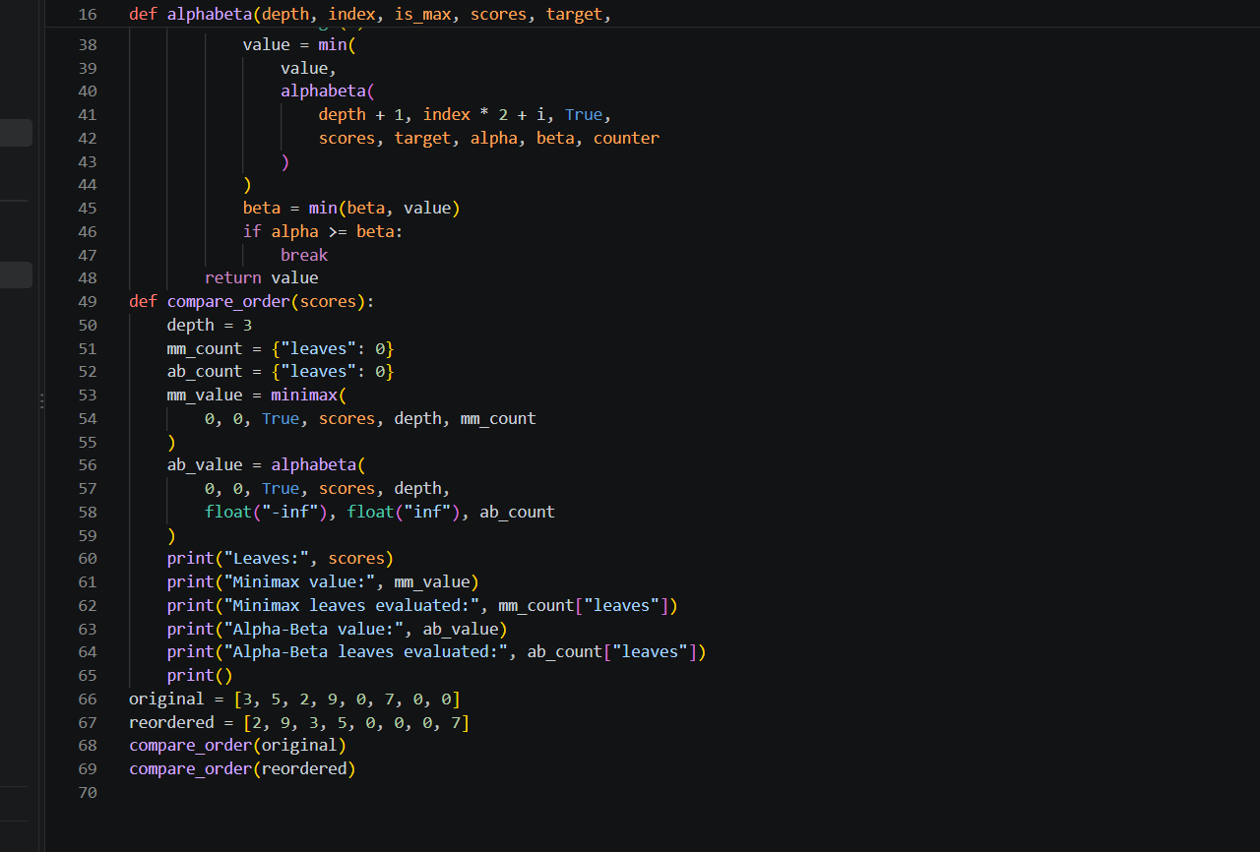

4. Expected output
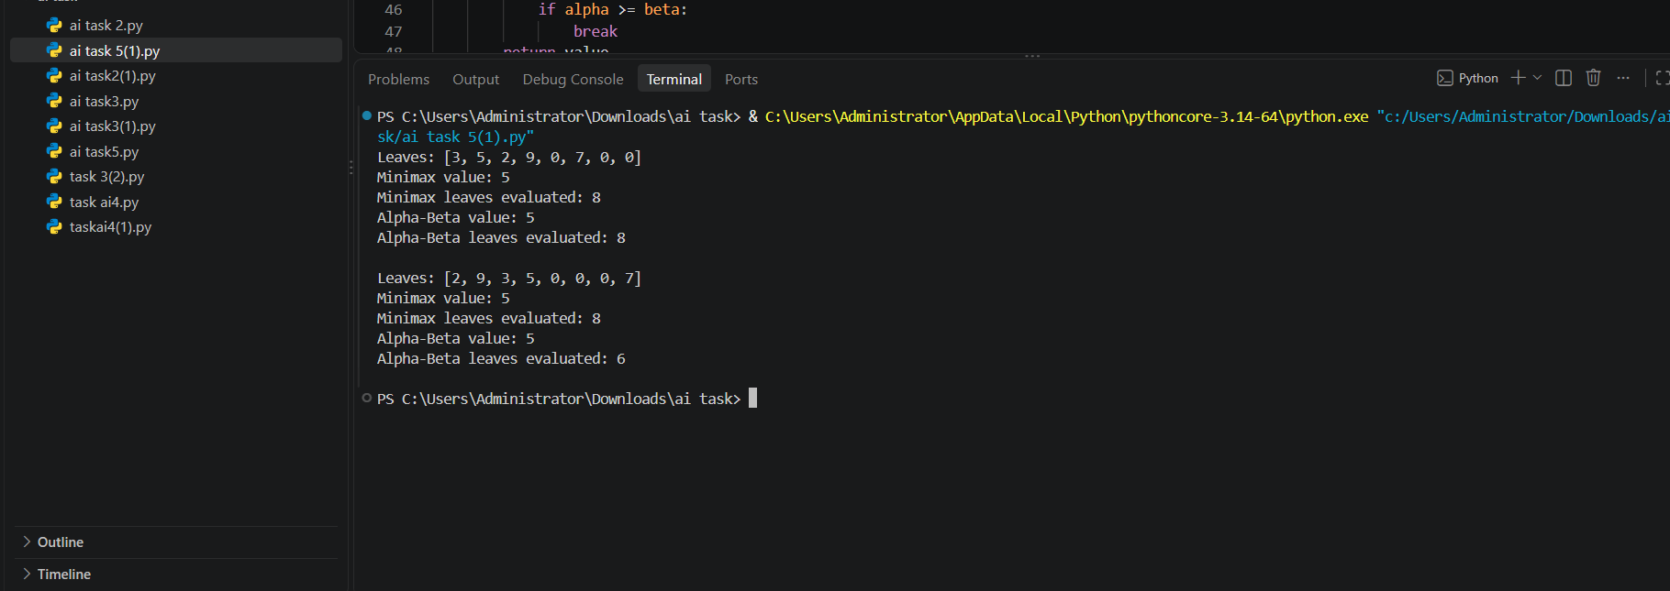
5. Results comparison
Branch order | Minimax value | Alpha-Beta value | Alpha-Beta leaves
Original | 5 | 5 | 8 of 8
Reordered | 5 | 5 | 6 of 8
In the reordered tree, the root MAX node first obtains alpha = 5 from the left subtree. At the right MIN node, the first child [0, 0] returns 0. This makes beta = 0, so beta <= alpha (0 <= 5). The remaining right-side child [0, 7] cannot affect the root decision and is pruned. Its two leaves are not evaluated. Therefore, Alpha-Beta evaluates 6 leaves instead of 8.
6. Interpretation and conclusion
The Minimax value remains 5 in both branch orders because changing the order of examining children does not change the game tree or its utilities. However, the number of leaves examined by Alpha-Beta changes: it evaluates all 8 leaves in the original order, but only 6 in the reordered order. This demonstrates that good move ordering improves pruning efficiency while preserving the optimal Minimax decision.
Plain Minimax evaluates all 8 leaves in both cases. Alpha-Beta pruning is therefore most useful when promising branches are examined early. The result also confirms the lab manual’s point that the amount of pruning depends on move ordering.

